Planning an Application: Lab 3

1. Clearly define the result (Output).

*************************************************************************

Prime Number Finder

*************************************************************************

XX2

XXX3

XXXXX5

XXXXXXX7

XXXXXXXXXXX 11

XXXXXXXXXXXXX13

XXXXXXXXXXXXXXXXX17

XXXXXXXXXXXXXXXXXXX19

XXXXXXXXXXXXXXXXXXXXXXXX23

Press the enter key to exit the program.

1. Determine what data is needed and how to get it (Input).

The data needed to complete this application is a prime number inputted from the user. The user must enter a prime whole number for the program to execute.

1. List the steps needed in between (Process).

* Once input has been obtained from user, we must use a try and except structure in order to determine whether the input is a whole numeric number and if it is within the range of 2-70.
* Once we have the whole numeric number inputted by the user, we must create a for loop iteration (since it is in sequence) with the starting point being the constant “2” and the end point being the user inputted variable.
* In the nested for loop iteration, there will be an if statement control structure to determine whether the end number inputted by the user is a prime number.
* Once it has been determined that it is a prime number it must go through another for loop iteration sequence and then break at the last prime number that is just before the end number that the user has inputted
* Then we must print all the prime numbers between 2 and the end number that the user has inputted
* After this we must apply an “X” bar that counts the amount of prime number listed in every new line.
* After this is completed we must prompt the user to press the enter key to exit.

1. Flow Chart

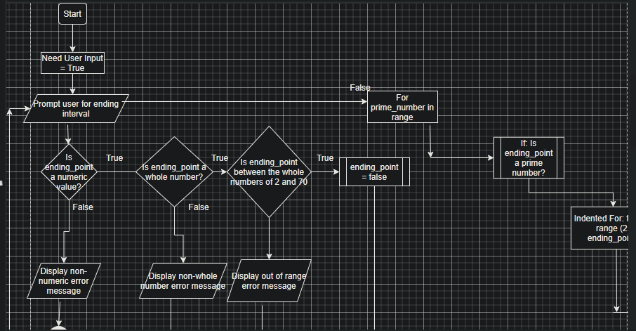

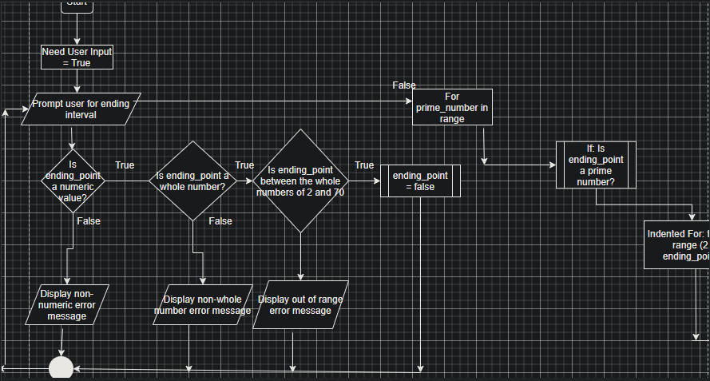

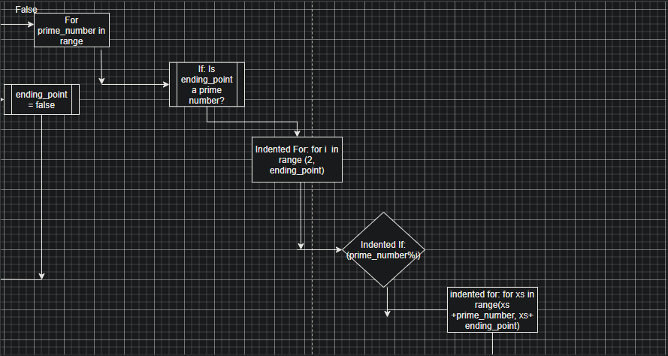

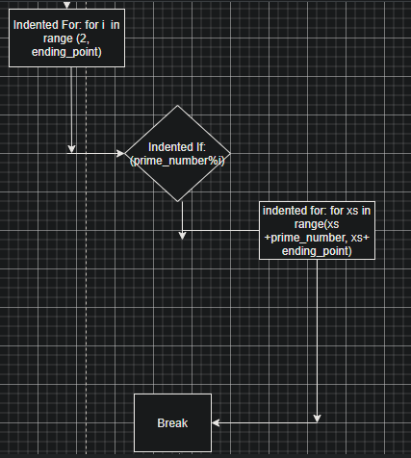

1. DeskCheck

|  |  |  |
| --- | --- | --- |
| Input | Results | Notes |
| Chicken | The value you entered must be a whole number. Please try again. | Non-Text therefore invalid |
| 4.5 | The value you entered must be a whole number. Please try again. | This number had a decimal place. This needs to be a whole number aka Integer |
| 999 | The value you entered must be between the numbers 2 and 70. Please try again. | This number is outside of the range. |
| 12 | XX 2  XXX3  XXXXX5  XXXXXXX7  XXXXXXXXXXX11 | This number that has been inputted by the user is a numeric, whole number and is within the range listed. |

Variables and Constants:

|  |  |  |
| --- | --- | --- |
| Constant/Variable | Name | Type |
| Constant | STARTING_POINT = 2 | int |
| Variable | ending_point = int(input(“Please enter an ending number between 2 and 70: ”)) | Int(input) |
| Constant | TWO_XS = xx | Str |
| Constant | THREE_XS = xxx | Str |
| Constant | FIVE_XS = xxxxx | Str |
| Constant | SEVEN_XS = xxxxxxx | Str |
| Constant | ELEVEN_XS = xxxxxxxxxxx | str |
| Constant | THIRTEEN_XS = xxxxxxxxxxxxx | Str |
| Constant | SEVENTEEN_XS = xxxxxxxxxxxxxxxxx | Str |
| Constant | NINETEEN_XS = xxxxxxxxxxxxxxxxxxx | Str |
| Constant | TWENTYTHREE_XS= xxxxxxxxxxxxxxxxxxxxxxx | Str |
| Constant | TWENTYNINE_XS= xxxxxxxxxxxxxxxxxxxxxxxxxxxxx | str |
| Constant | THIRTYONE_XS = xxxxxxxxxxxxxxxxxxxxxxxxxxxxxxx | Str |
| Constant | THIRTYNINE_XS = xxxxxxxxxxxxxxxxxxxxxxxxxxxxxxxxxxxxxxxxxxxx | Str |
| Constant | FOURTYONE_XS =  xxxxxxxxxxxxxxxxxxxxxxxxxxxxxxxxxxxxxxxxxxxxxx | Str |
| Constant | FOURTYTHREE_XS =  Xxxxxxxxxxxxxxxxxxxxxxxxxxxxxxxxxxxxxxxxxxxxxxxx | str |
| Constant | FOURTYSEVEN_XS =  Xxxxxxxxxxxxxxxxxxxxxxxxxxxxxxxxxxxxxxxxxxxxxxxxxxxx | str |
| Constant | FIFTYTHREE_XS =  XxxxxxxxxxxxxxxxxxxxxxxxxxxxxxxxxxxxxxxxxxxxxxxxxxxxXXXXXX | Str |
| Constant | FIFTYNINE_XS =  XxxxxxxxxxxxxxxxxxxxxxxxxxxxxxxxxxxxxxxxxxxxxxxxxxxxXXXXXXxxxxxx | str |
| Constant | SIXTYONE_XS =  XxxxxxxxxxxxxxxxxxxxxxxxxxxxxxxxxxxxxxxxxxxxxxxxxxxxXXXXXXxxxxxxxx | str |
| Constant | SIXTYSEVEN_XS =  XxxxxxxxxxxxxxxxxxxxxxxxxxxxxxxxxxxxxxxxxxxxxxxxxxxxXXXXXXxxxxxxxxxxxxxx | str |